Skill 2
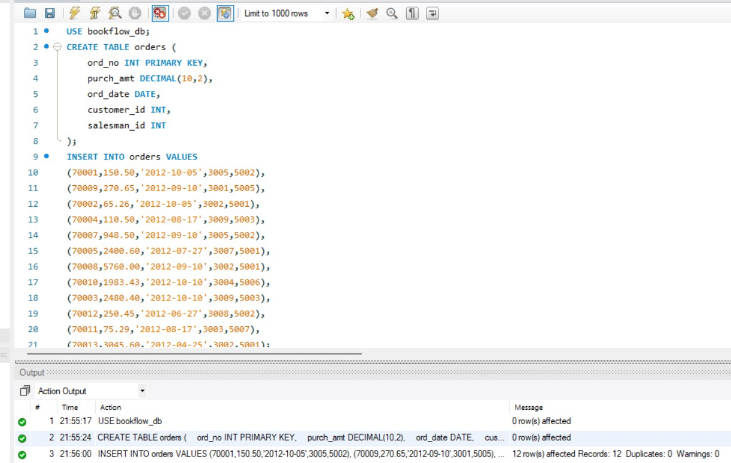
STEP 1: CREATE TABLE, INSERT DATA

QUESTION 1 - WHERE CLAUSE SCENARIO:
Finance wants all orders whose purchase amount is greater than $2,000.

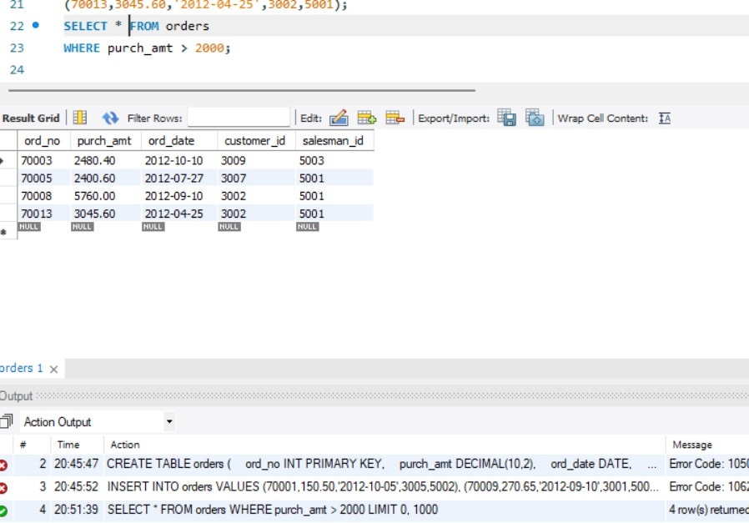

QUESTION 2 - WHERE CLAUSE SCENARIO:

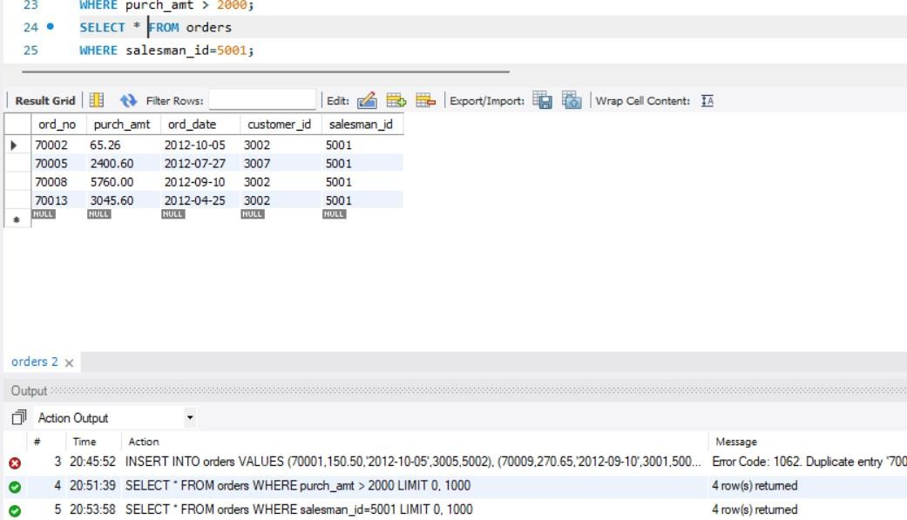
Find all orders handled by salesman 5001.

QUESTION 4 - ORDER BY SCENARIO:
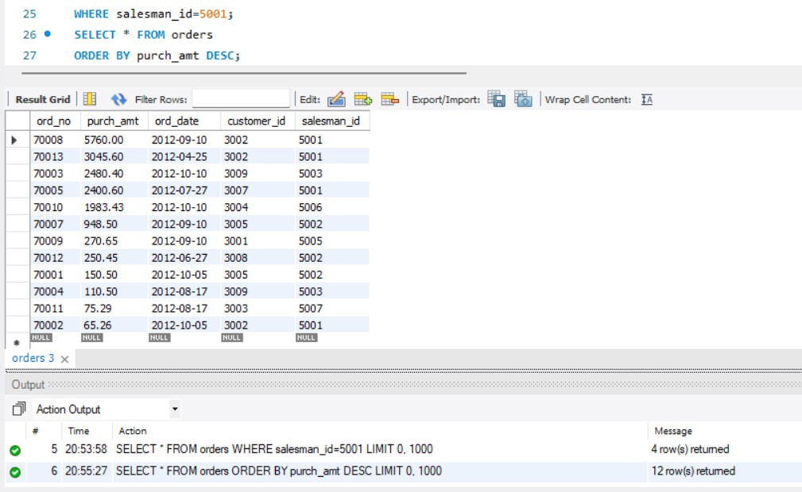
CEO wants to see orders ranked from highest amount tolowest amount

QUESTION 5 - ORDER BY SCENARIO:
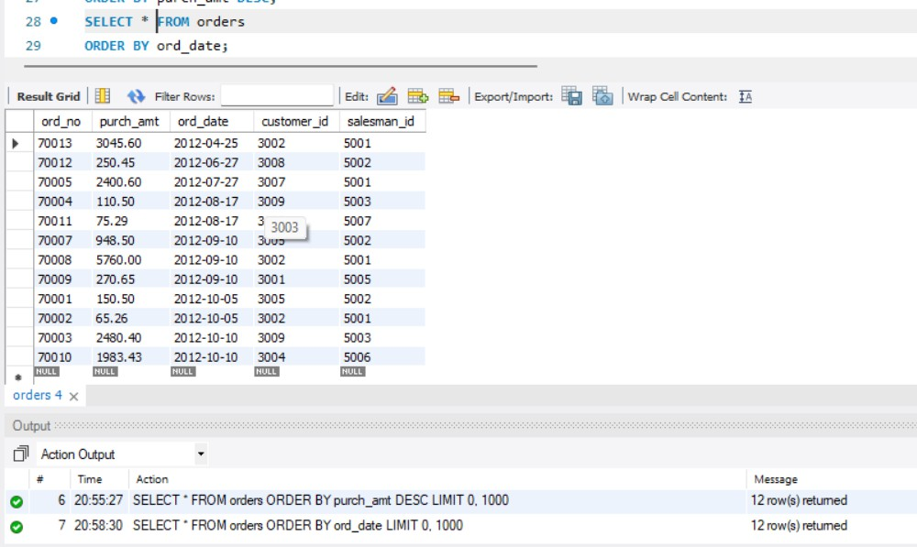
Operations team wants oldest orders first.

QUESTION 6 - SUM() SCENARIO:
Finance department wants total revenue generated.
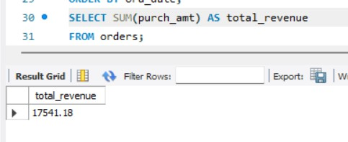

QUESTION 7 - AVG()

SCENARIO:
Management wants average order value.
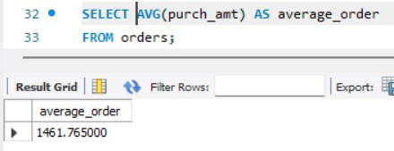
QUESTION 8 - MAX() SCENARIO:
Find the highest order amount.
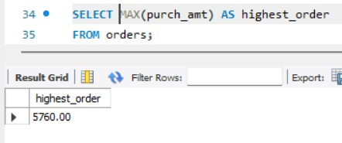
QUESTION 9 - MIN() SCENARIO:
Find the lowest order amount.
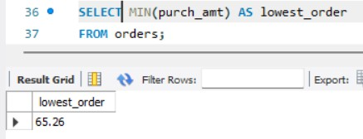

QUESTION 10 - COUNT()

SCENARIO:
Find total number of orders.
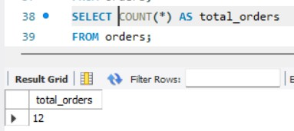
QUESTION 11 - GROUP BY SCENARIO:
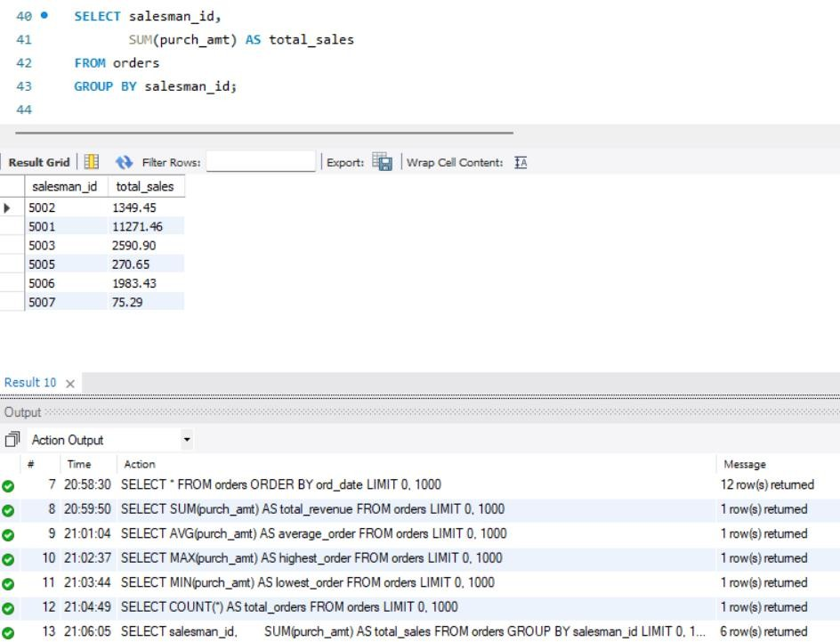
Sales director wants total sales generated by each salesman.

QUESTION 12 - GROUP BY

SCENARIO:
Marketing wants total purchases made by each customer.
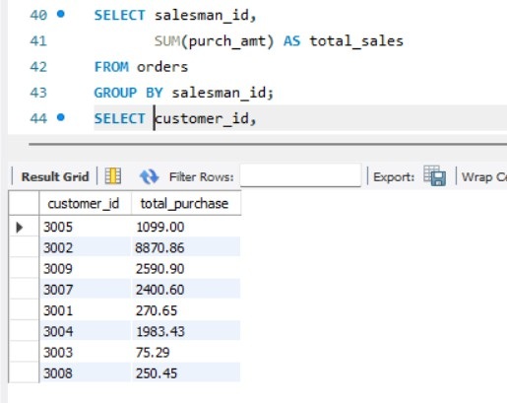
QUESTION 13 - GROUP BY + MAX() SCENARIO:
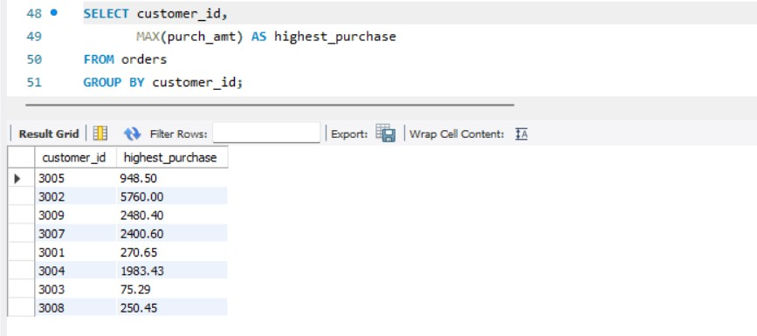
Find the highest order placed by each customer.

QUESTION 14 - GROUP BY + HAVING SCENARIO:

Company rewards salesmen whose total sales exceed $3,000.
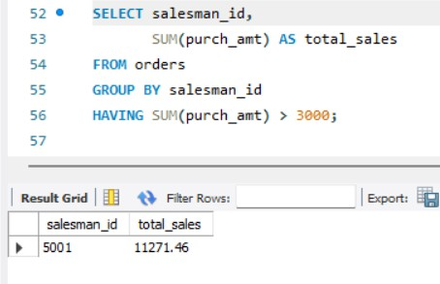
QUESTION 15 - GROUP BY + HAVING SCENARIO:
Find customers whose total purchases exceed $2,500.
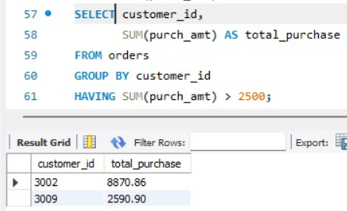
QUESTION 16 - GROUP BY + HAVING SCENARIO:

Find customers who placed more than one order.
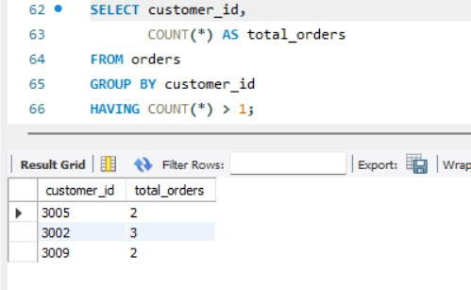
QUESTION 17 - GROUP BY + HAVING + ORDER BY SCENARIO:
Management wants top customers ranked by spending.
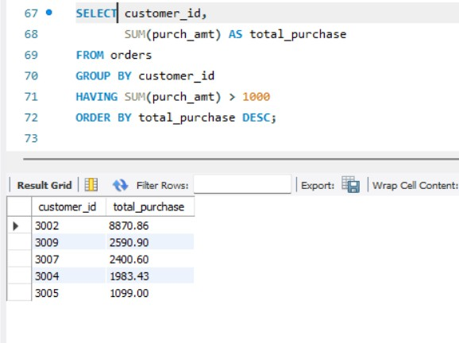

QUESTION 18 - BETWEEN + HAVING

SCENARIO:
Find customers whose maximum purchase is between
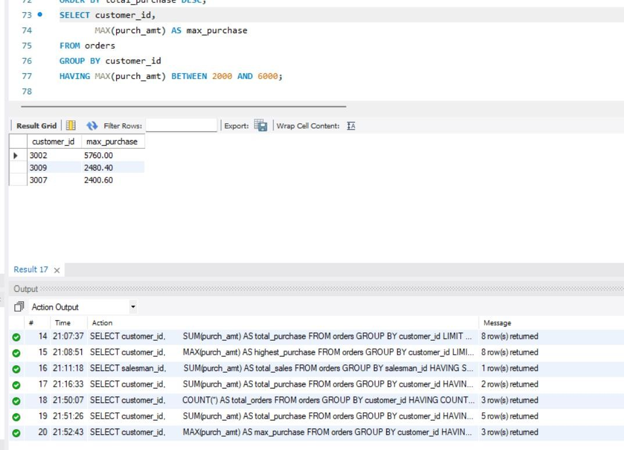
$2,000 and $6,000.

QUESTION 19 - COUNT + HAVING SCENARIO:
Find salesmen who handled at least two orders.
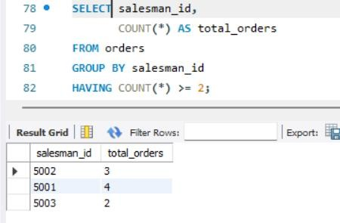

QUESTION 20 - MAX + GROUP BY + HAVING SCENARIO:
Management wants daily highest purchases above $2,000.
